**Assignment 2**

**Problem 1** has been solved on gams and the code is posted in GitHub.

**Problem 2:**

The decision variables refer to the quantities that the decision makers would like to determine. For the problem, the total transportation cost is the decision variable. The tariff and the maximum usage determine the decision variable.

The formulation for the minimum cost problem is as follows:

If the complete flow occurs, that is the demand is 1200

From Origin node 1, demand = 1200

Destination node 4, demand = -1200

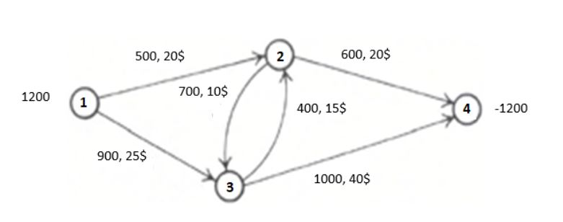 $$Min Z=\sum_{(i,j)∈U}{C\left(i,i\right) f(i,j)}$$

Subjected to: U = Link capacity

$f(i,j)$ ≤ $U(i,j)$*f* = Positive variable

$$\sum_{j∈U(i,j)}{f\left(i,j\right) }- \sum_{j∈U\left(i,j\right)}{f\left(j,i\right) }=b(i)$$

$f(i,j)$ ≥ 0 C = Link Cost

b = Demand

**Problem 3:**

For this problem, using integer programming it has been solved and the GAMS code has been uploaded to GitHub

For the branch and bound approach, initially it has been solved by linear programming and the outcome gave us the upper integer and lower integer value.

The Branch and bound approach are shown below:

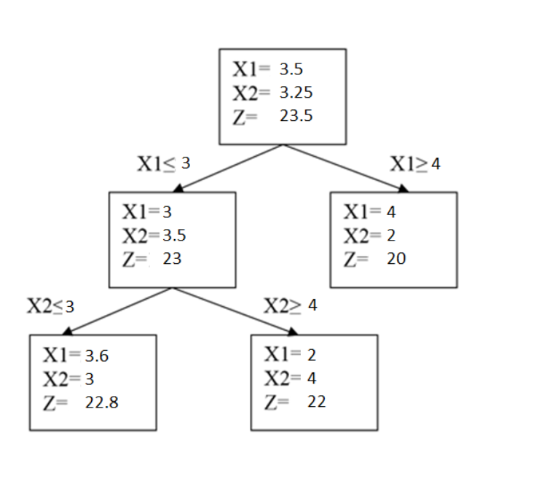

The encircled one matches with the integer programming solution. As the problem stated to maximize the equation. Hence the encircled one is the optimum solution.

**Problem4:**

In this problem, the capacity of the warehouse has been given as M(i)

The formulation is as follows:

Minimizing: $$\sum_{i=1}^{m}{\sum_{j=1}^{n}{c_{ij}x_{ij}}}+ \sum_{j=1}^{m}{f_{i}y_{i}}$$

Subject to:

$\sum_{j=1}^{m}{x_{ij}}$ = *dj* d= demand

$\sum_{j=1}^{m}{x_{ij}}$ ≤ *Mj* M= Capacity

- *yi* ≤ 0

$x_{ij}$ ≥ 0 X = Positive Variable

*yi* = 0 or 1 Y = Binary Variable

The problem has been solved in GAMS and the code has been uploaded in GitHub.